Software Requirements Specification
for
Rich n’ Famous Rental Car
Version 1.1
Prepared by Nathan Brooks
June 19, 2015

Table of Contents
1. Introduction 1
1.1 Purpose and Intended Audience 1
1.2 Project Scope 1
1.3 Terms, Definitions, and Acronyms 1
1.4 References 1
2. Overall Description 2
2.1 Product Perspective 2
2.2 Product Features 2
2.3 User Classes and Characteristics 2
2.4 Operating Environment 3
2.5 Design and Implementation Constraints 3
2.6 Assumptions and Dependencies 3
3. System Features 3
4. Non-Functional Requirements 4
5. External Interface Requirements 5
5.1 User Interfaces 5
5.2 Hardware Interfaces 5
5.3 Software Interfaces 5
5.4 Communication Interfaces 5
6. Detailed Use Cases 6
6.1 - Use Case Diagram 6
6.2 – Reserve Vehicle Activity Diagram 7
6.3 – Reserve Vehicle Use Case Description 8
6.4 – Create Customer Account 9
6.5 – Create Customer Account Use Case Description 10
7. Overview Class and Domain Class Diagrams 11
7.1 Overview Class Diagram 11
7.2 Employee Domain Class Diagram 12
7.3 Reservation Domain Class Diagram 13
7.4 Vehicle Domain Class Diagram 14
8. Sequence, Communication, and State Machine Diagrams 15
8.1 8.1 Check-in Vehicle Sequence Diagram 15
8.2 Claim Sequence Diagram 16
8.3 Reserve Vehicle Communication Diagram 17
8.4 Maintenance Communication Diagram 18
8.5 Mobile Laser/Scanner Computer Handheld Device State Machine 19
9. Appendix A 21
9.1 Rich n’ Famous Rental Car Scenario for CS 2450 Homework 1-9 21

Revision History
Name | Date | Reason For Changes | Version
Nathan Brooks | 6-3-15 | Creation | 1.0
Nathan Brooks | 6-19-15 | Additions for clarification  Added “Detailed Use Cases” | 1.1
Nathan Brooks | 7-5-15 | Added section “Overview Class and Domain Class Diagrams” | 1.2
Nathan Brooks | 7-12-15 | Added section “Sequence, Communication, and State Machine Diagrams” section | 1.3

Introduction
The system that will be developed will track the status and location of vehicles and will provide information for associates to look up as to provide more information to the customers. The system will also provide a web interface for customers to rent vehicles.

Purpose and Intended Audience
The purpose of this document is to act as a contract between Rich n’ Famous Rental Car and the development team. It will lay out the plans of development.

Project Scope
This product will provide organization and efficiency to an already established business by tracking vehicles and data more thoroughly.

Terms, Definitions, and Acronyms
- Cloud storage – the information stored on the server that can be accessed remotely.
- Dev team – Development team.
- LP – Legal personnel.
- MP – Maintenance personnel.
- OS – Operating System.
- Proxy – a computer that is used as a bridge from the scanners
- Server – The computer that stores information and distributes information when requests are made.
- WS – Web site.

References

The information obtained about the planned system was found in:
- A document created by Rich Fry
- A video recording made by Rich Fry explaining the document.

Overall Description

Product Perspective
This system will be independent, it will not require any interfacing with other systems, it is self-contained. Users will access the system via computers on site but customers will be able to access the web site to place orders.
Payment
Processing

 |  |  |  | Main System | <---- | MP
 |  |  |  | Main System | <---- | LP
customers | ----> | Web site | ----> | Main System
 |  |  |  | Main System | <---- | Clerks
 |  |  |  | Main System | <---- | Management

Product Features
- Database of vehicles in stock
- Database search-ability
- Digitized maintenance records
- Maintenance alerts
- Interfaces with hand-held wireless scanners that are also POS machines
- Ability to track individual vehicle revenue, expense history, number of times rented, reservation history and status, etc.
- Accident reports and / or insurance claims associated with individual vehicles
- Flags for vehicles that are close to “expiring” (reaching 1 year old)
- Online catalog
- Online system allows for varied customer statuses (e.g. privileged customers that receive discounts and advanced reservations of special vehicle types)
- Web site allows scheduling of vehicle deliveries and pickup to and from customers’ homes
- Web site does everything that can be done by speaking to a representative.

User Classes and Characteristics
- Employees will be trained to use the system, but will not be required to have an expert knowledge of computers. The will need to understand how to create reports and be able to navigate a modern Windows OS.
- Managers will need to understand how to use more of the system than the hourly workers.
- Customers using the web site will only need to know how to fill out forms and click on what they want.

Operating Environment
The system is intended to be used on computers located at each retail location and can be used by many employees at the same time. The scanners used by some employees will access the main database by using a local computer as a proxy. The only part of the system that will be used outside the control of each location will be the web site that can be accessed by customers.

Design and Implementation Constraints
This system must be able to interact with the local DMV offices in all 50 states as well as be able to interface with insurance companies.

Assumptions and Dependencies
This system must be completed within two years of start date.

System Features
Example: The completed system will provide the following functionality to all users (in general) and will include the ability to:

- Manage (add, update) reservations
- Manage (add, update, delete) user profiles
- Query database for any vehicle information
- Place requests for maintenance and repairs

Specific functionality for managers & owners (only) will include the ability to:

- Manage (add, update, and delete) inventory items
- Override sales totals and offer a discount
- Perform all the functions listed under the employee (legal, maintenance, and clerk) roles
- Complete maintenance and repair requests

In addition, specific functionality for maintenance personnel will include the ability to:

- Generate vehicle history reports
- Add “work done” and “work needed” attributes to vehicles

Clerks will have the ability to:

- Interface the POS scanners with a local machine to add sales information automatically after finishing the POS functions.

Non-Functional Requirements
Operational
- This system will operate on any desktop computer at any of the six locations owned by Rich Fry
- The web site will be written in a way to work on any internet browser
Performance
- The system should be accessible as long as maintenance is not being done to the system, which will be completed over night to reduce inconveniences.
- The servers should have a capacity large enough to accommodate 100 times the expected yearly storage requirement
- The system will be updated in real time, information in the database should be as close to real time as possible
- Queries to the server should return within 10 seconds of a request being sent
- The web site should run fast enough to have pages load in at most 4 seconds with an optimal connection
- The web site should show customers their own order history and due dates
Security
- Only direct managers can see personnel records
- Customers will not be able to see anything but their own order history and due dates
- Maintenance personnel will not be able to see legal or sales information
- Clerks will not be able to change sales information after it has been submitted, it will require management to make changes
Cultural and Political
- The system will comply with insurance industry standards
- The system should be able to distinguish what state a customer is using the web site in in case there are any specific local laws that need to be accounted for

External Interface Requirements

User Interfaces
This section describes any external system user interfaces that may be required by the system, e.g., a console window.

Hardware Interfaces
This section describes any external system hardware interfaces, e.g., an analog to digital converter that may be required by the system.

Software Interfaces
This section describes any external software interfaces, e.g., input files to this system that were created by another software system.

Communication Interfaces
This section describes any external communication interfaces, e.g., TCP/IP communication sockets that are necessary for the operation of this system.

Detailed Use Cases

- Use Case Diagram

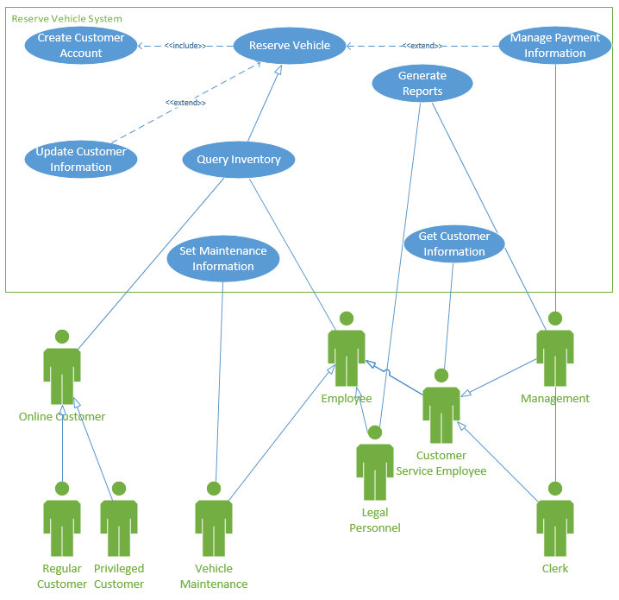
Overview of entire system.

– Reserve Vehicle Activity Diagram
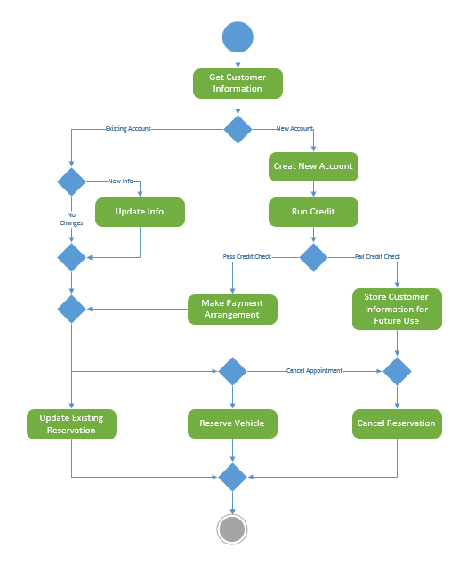
Explains the flow and decisions required for reserving a vehicle.

– Reserve Vehicle Use Case Description
Use case name: Reserve Vehicle | ID:1 | Importance Level: High
Primary actor: Customer Service | Use case type: Essencial
Stakeholders and interests:
Management, Clerks, Customer(online)

Brief description: This use case describes how a vehicle is reserved for rental.
Trigger: A previous tenant moves out so the unit is available. The owner or campus housing can list the unit as available.
Relationships:
Association: Query Inventory
Include: Create Customer Account
Extend: Manage Payment Information, Update Customer Information
Generalization:

Normal flow of events:
- Create Customer account
- Run a credit check.
- Make payment arrangements
- Reserve vehicle

Subflows:

Alternate/exceptional flows:
- Update customer information
- Cancel reservation
- Update current reservation

– Create Customer Account
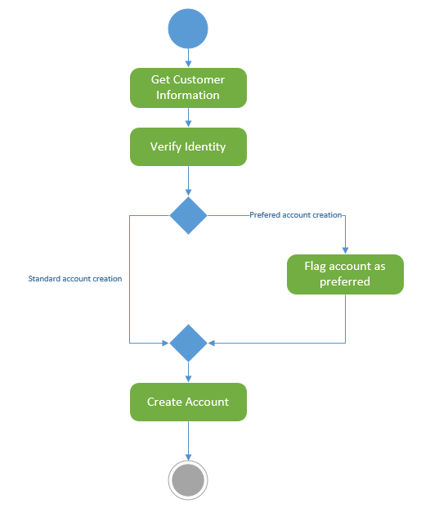
Explains the how a customer account is created

– Create Customer Account Use Case Description
Use case name: Create Customer Account | ID:2 | Importance Level: High
Primary actor: Customer Service | Use case type: Essencial
Stakeholders and interests:
Management, Clerks, Customer(online)

Brief description: This use case describes how a Customer Account is created.
Trigger: A new customer wants to make an account to allow them to rent a vehicle.
Relationships:
Association:
Include: Reserve Vehicle
Extend:
Generalization:

Normal flow of events:
- Customer either comes in, calls, or gets on the web site.
- Customer must have an account created before they can rent a vehicle.

Subflows:
none

Alternate/exceptional flows:
Become a Preferred Customer
- Customer has the option to become a Preferred Customer at this time to allow discounts and other services when they rent a vehicle.

Overview Class and Domain Class Diagrams

Overview Design Class Diagram 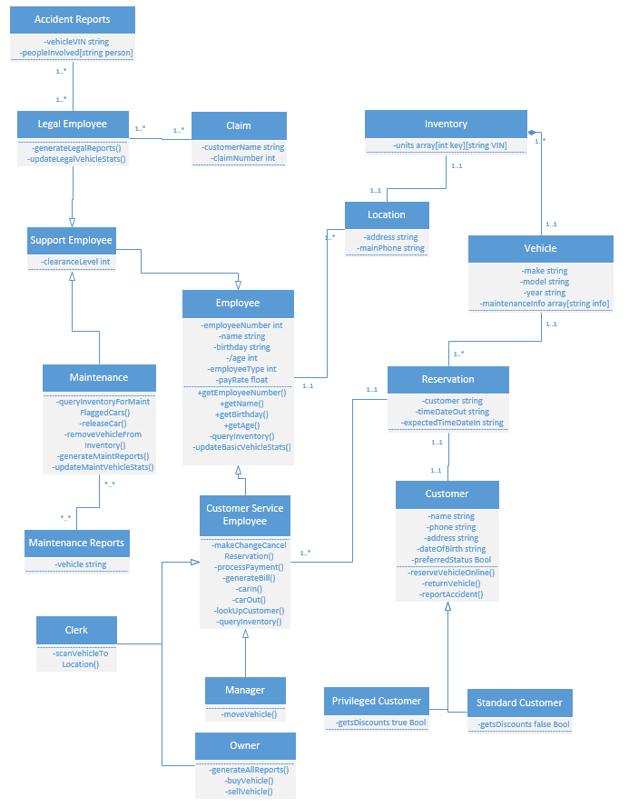

This diagram displays an overview of the entire system showing the normal flow of entire business.

Employee Domain Class Diagram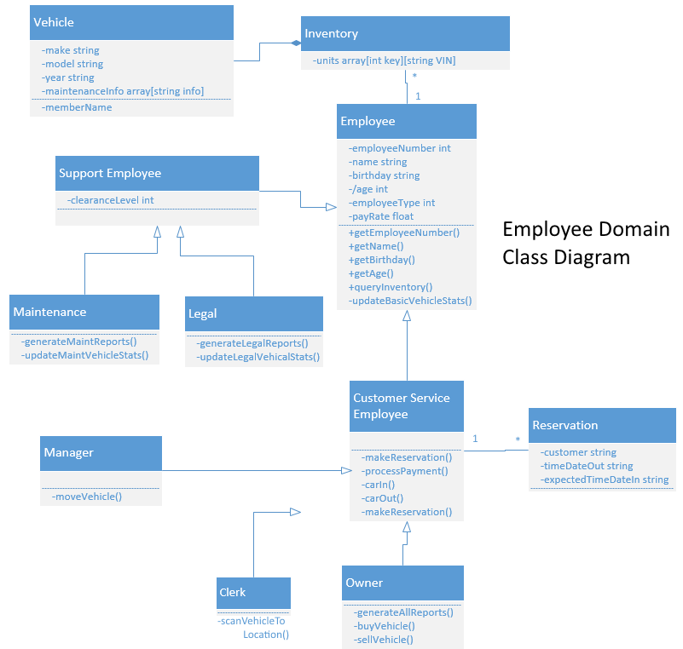
Domain class diagram for Employees, shows relationship employees have with the business.

Reservation Domain Class Diagram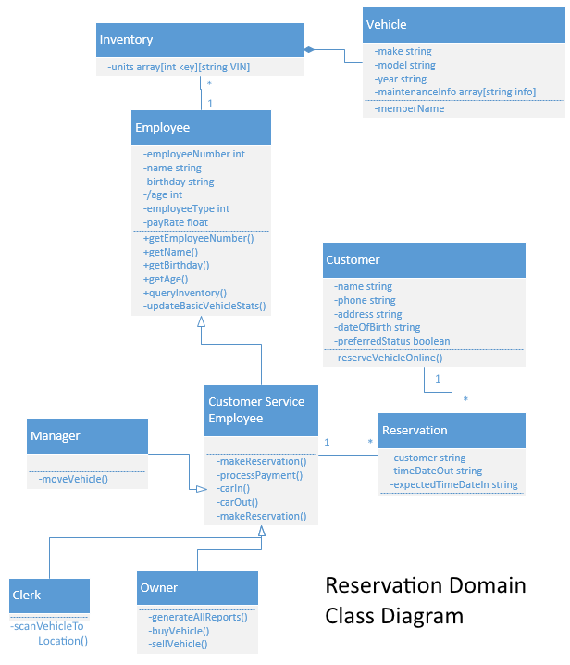
Domain class diagram for reservation, shows the relationship employees and customers have with the system to reserve vehicles.

Vehicle Domain Class Diagram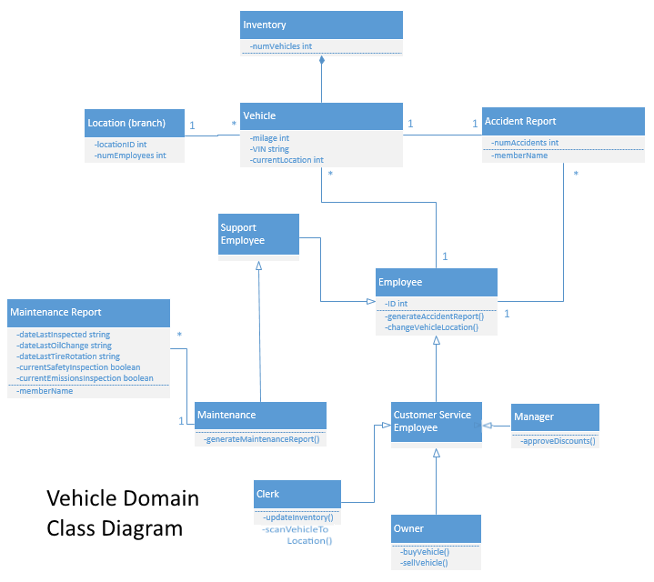
Domain class diagram for vehicle, shows relationship with employees and locations.

Sequence, Communication, and State Machine Diagrams

8.1 Check-in Vehicle Sequence Diagram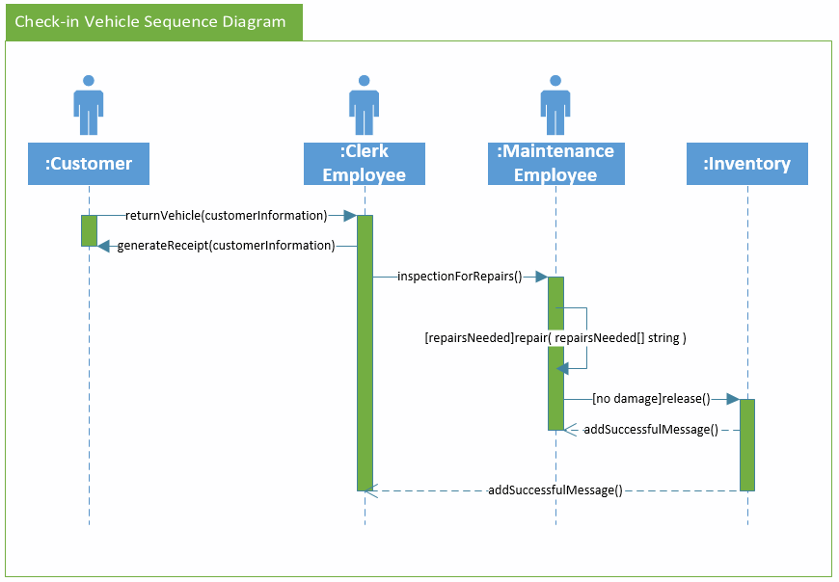
A sequence diagram for vehicle check-ins. Shows an anticipated timeline of steps that will occur during check-in.

Claim Sequence Diagram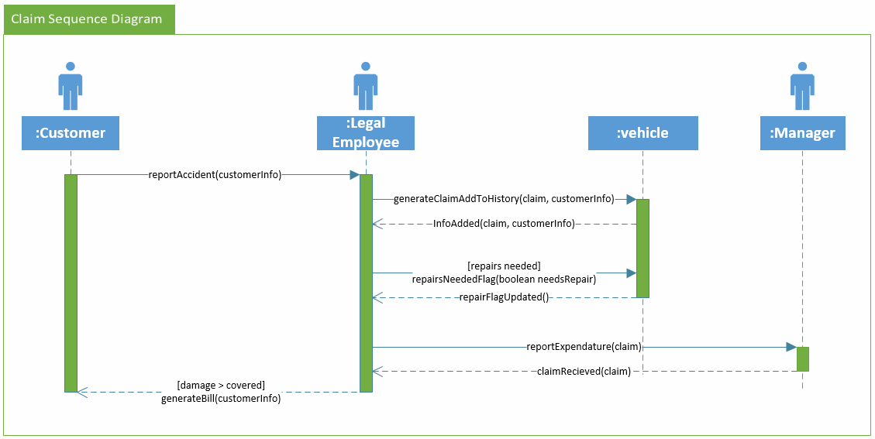
A sequence diagram for claims. Shows an anticipated timeline of steps that will occur when a claim is made.

Reserve Vehicle Communication Diagram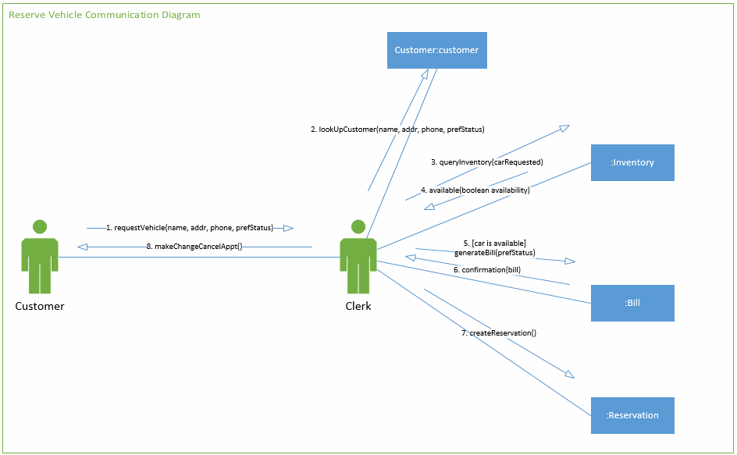
Communication diagram for reserving a vehicle. Shows the communication path required to reserve a vehicle.

Maintenance Communication Diagram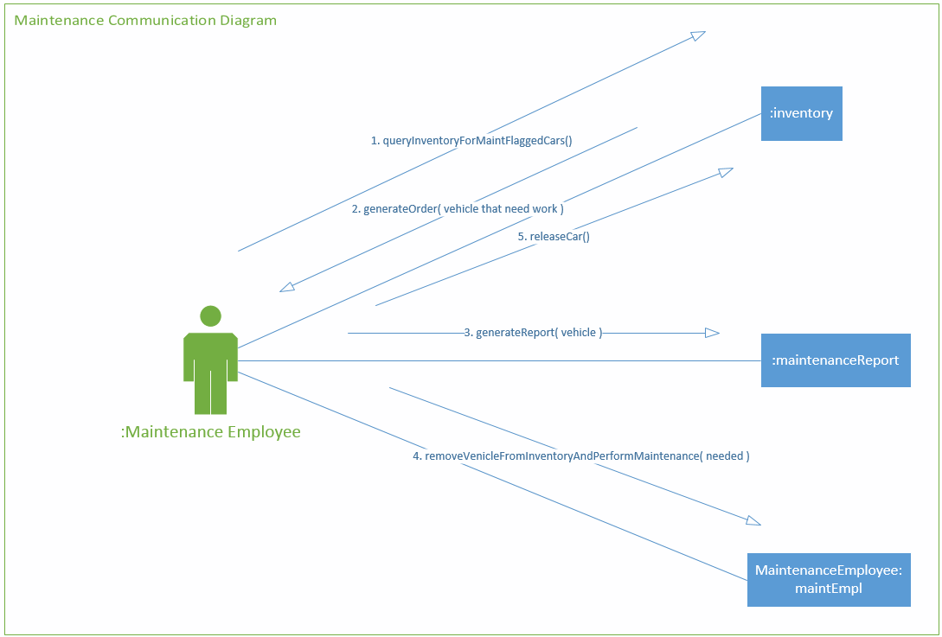
Communication Diagram showing the communication path maintenance employees will take when they check what vehicles have been flagged as “needs maintenance”.

Mobile Laser/Scanner Computer Handheld Device State Machine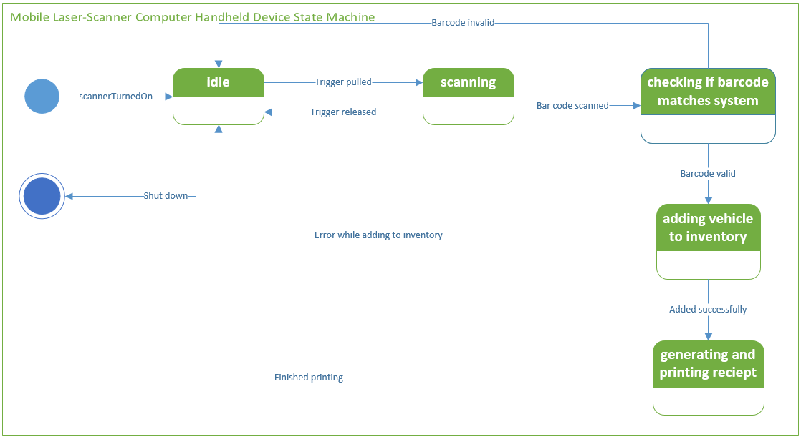

APPENDIX

Appendix A

Rich n’ Famous Rental Car Scenario for CS 2450 Homework 1-9

